Planck’s Rainbow

<https://github.com/penoel/Planck_rainbow>

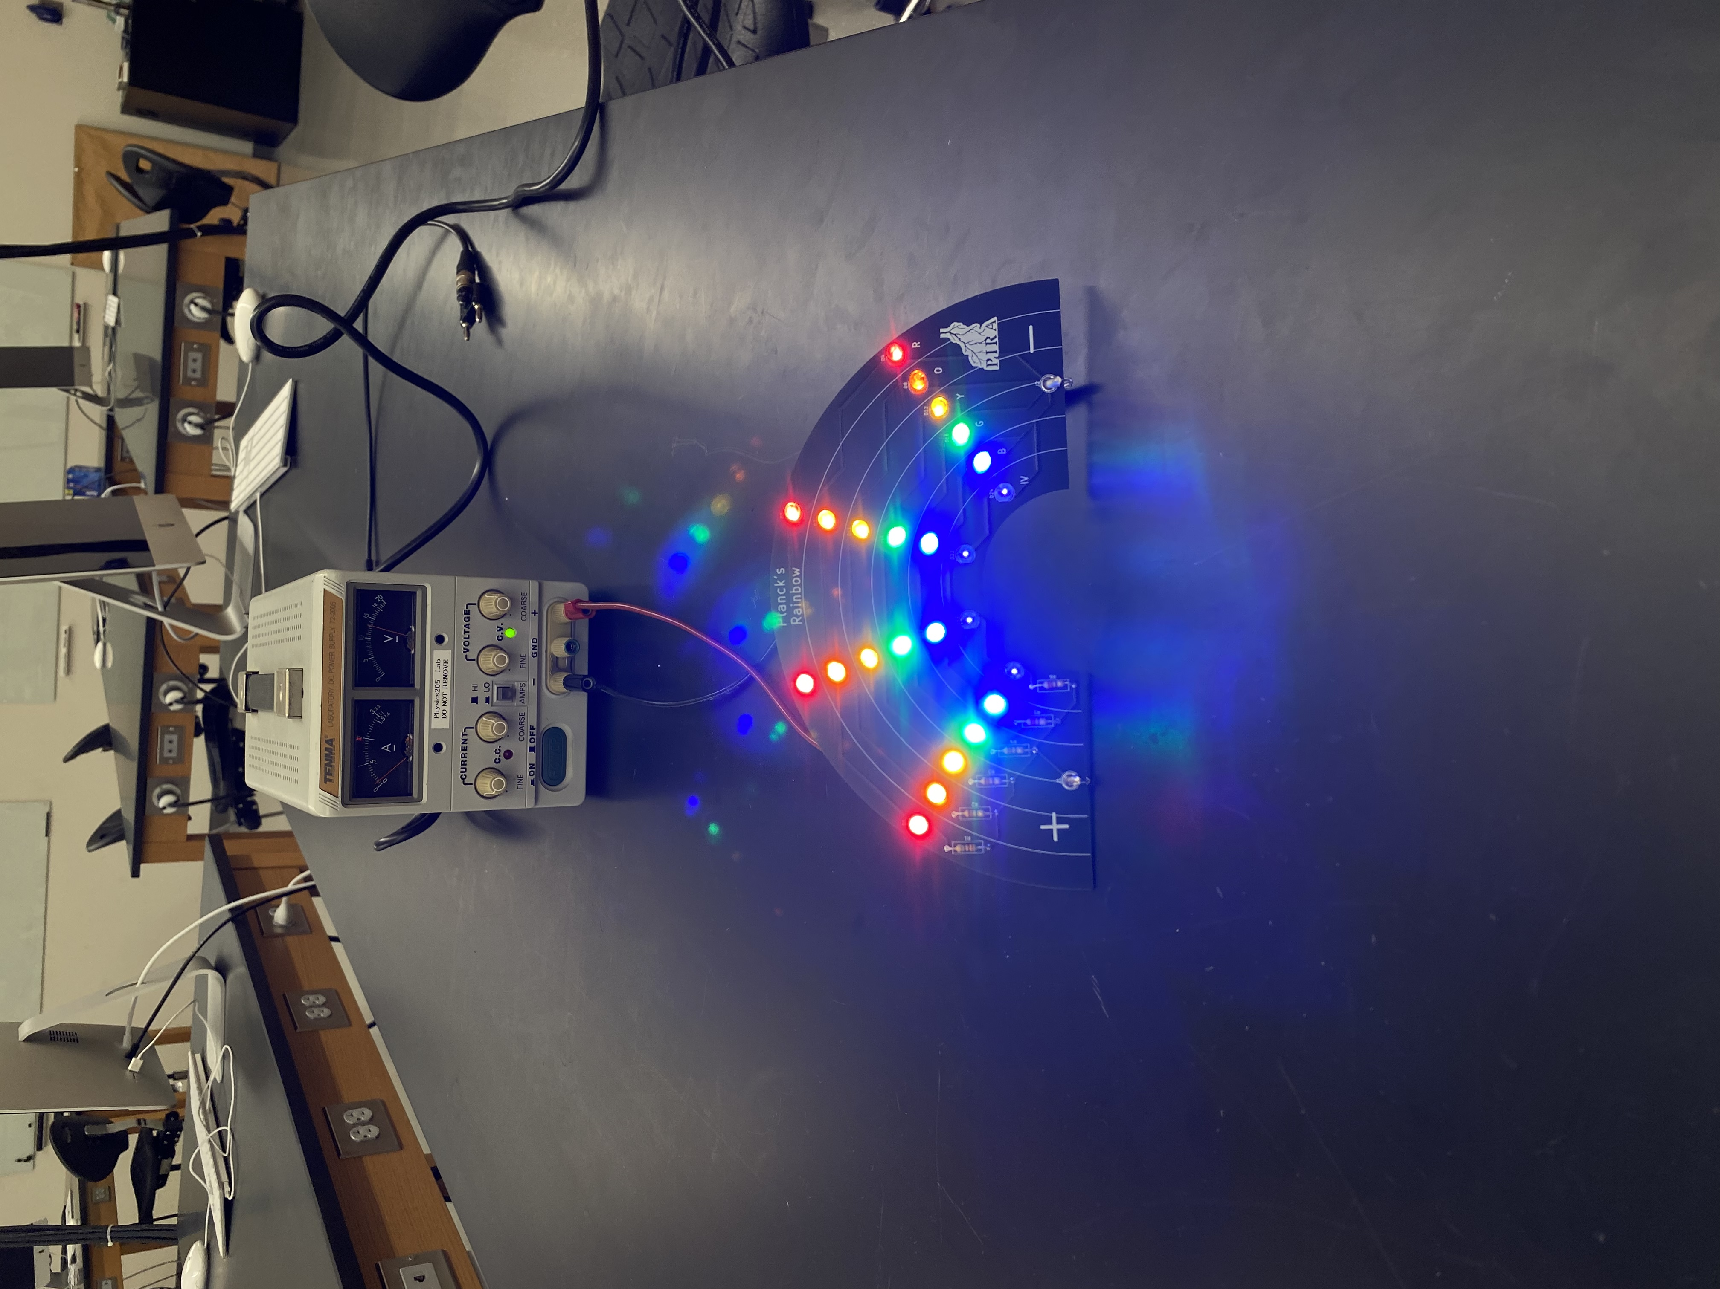

The Planck’s Rainbow apparatus is used to demonstrate the energy wavelength relationship. It comprises 6 branches with each branch in parallel. Each branch has a resistor in series with 4 leds of the same color. Each led has a distinct turn on voltage. For the branch to light the voltage must increase above the turn on voltage for all four leds added. If the voltage increases more the voltage drop across the leds stay the same and the voltage drop across the resistor increases. If the voltage increases high enough the next branch will light.

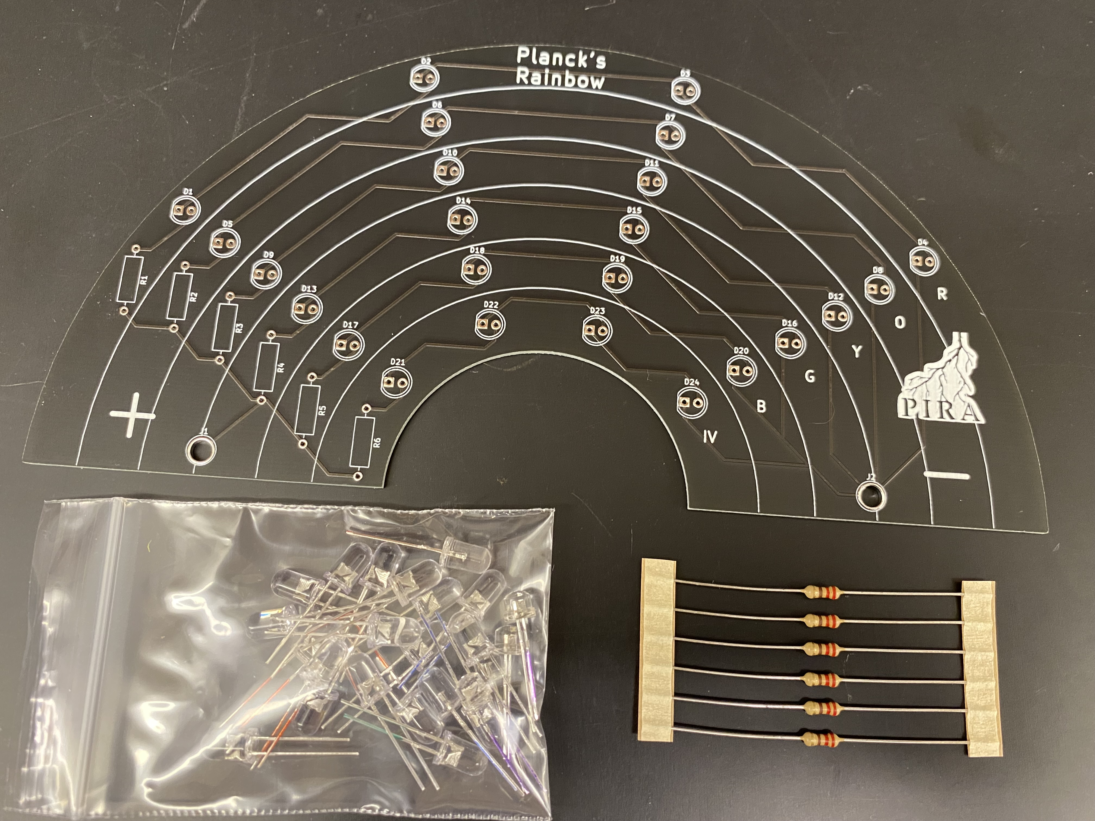

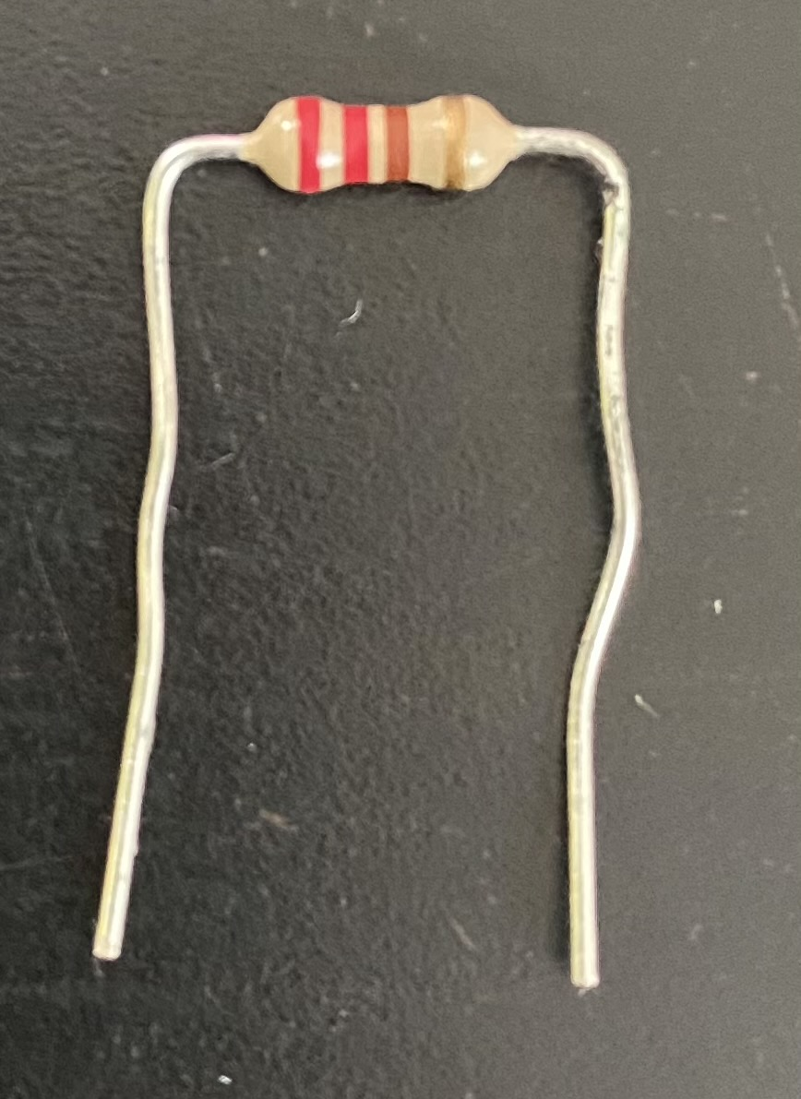

The Rainbow kit contains the following components:

* 1 – PCB
* 4 – Red led
* 4 – Yellow led
* 4 – Blue led
* 6 – 220 $Ω$ resistors
* 4 – Orange led
* 4 – Green led
* 4 – UV/purple led
* Take the pcb and 6 resistors out of the bag.
* Bend the legs of the resistor, place them in the pcb, and bend the legs so they won’t fall out.
* Solder the resistors and trim the legs.
* Take the red marked leds and place them in the top row of the pcb (make sure that the flat part of the led is matched with the pcb screen print shape.) Bend legs so they don’t fall out.
* Solder the leds and trim the legs.
* Repeat for the orange (next most outside row), then do the same for yellow (unmarked), green, blue, uv/purple.

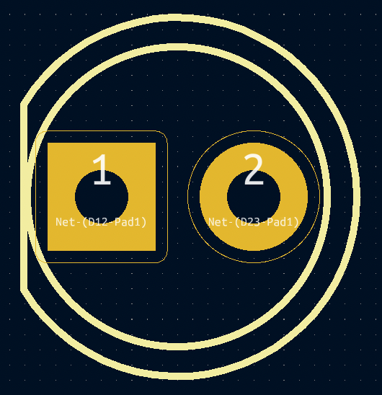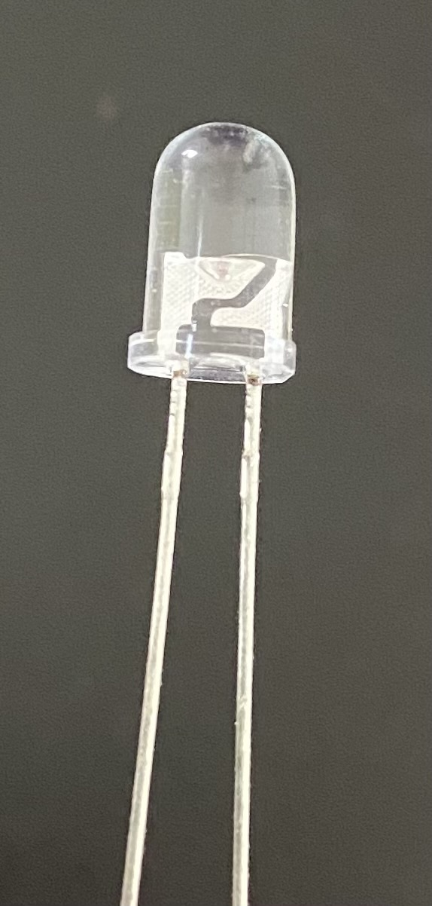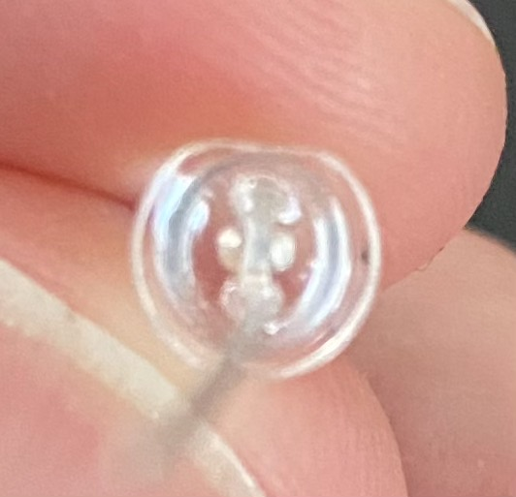

**Rainbow operation**

You can hook up a genecon and spin it at different speeds to light up more and more led branches. You can also hook it up to a variable dc power supply (at least 15V) and turn it up watching more branches light.

